**Template Driven Forms**

1. **Create bootstrap form**

<form>

<div class="form-group">

<label for="firstName">First Name:</label>

<input id="firstName" type="text" class="form-control">

</div>

<div class="form-group">

<label for="comment">Comments:</label>

<textarea name="" id="comment" cols="" rows="" class="form-control"></textarea>

</div>

<button class="btn btn-primary">Submit</button>

</form>

**2.)Types of Forms**

In angular we have a class called **FormControl**

For each input field in our form we need to create instance of a control class and with this control class we can check lot of things, they are

* **Value** – input field current value
* **Touched** – input field touched
* **Untouched** - input field untouched
* **Dirty** - input field value is changed
* **Pristine** - input field is not changed
* **Valid** - input field is valid
* **Errors** -if input field is not valid what is the error

**FormGroup**

In angular we have an another class called **FormGroup**

Which represent group of **FormControl** in a **FormGroup**

Same control classes available for **FormControl** also

* **Value** – input field current value
* **Touched** – input field touched
* **Untouched** - input field untouched
* **Dirty** - input field value is changed
* **Pristine** - input field is not changed
* **Valid** - input field is valid
* **Errors** -if input field is not valid what is the error

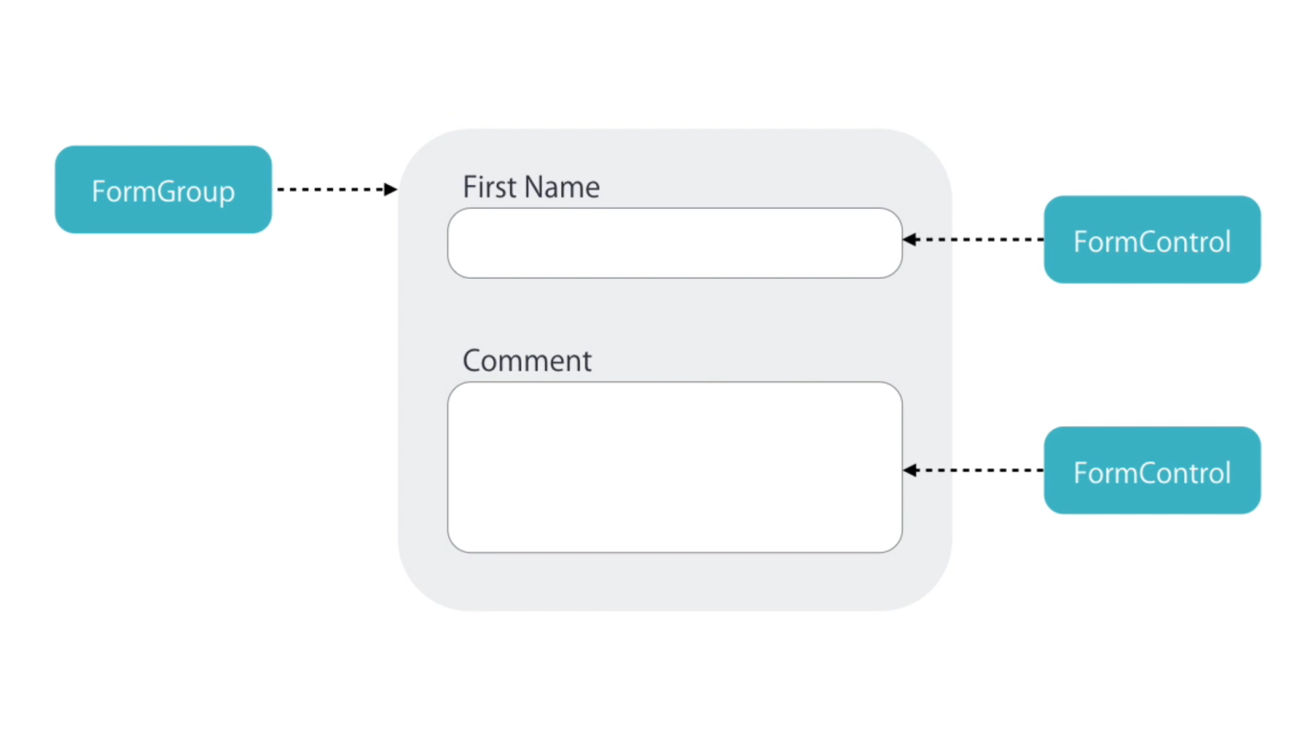

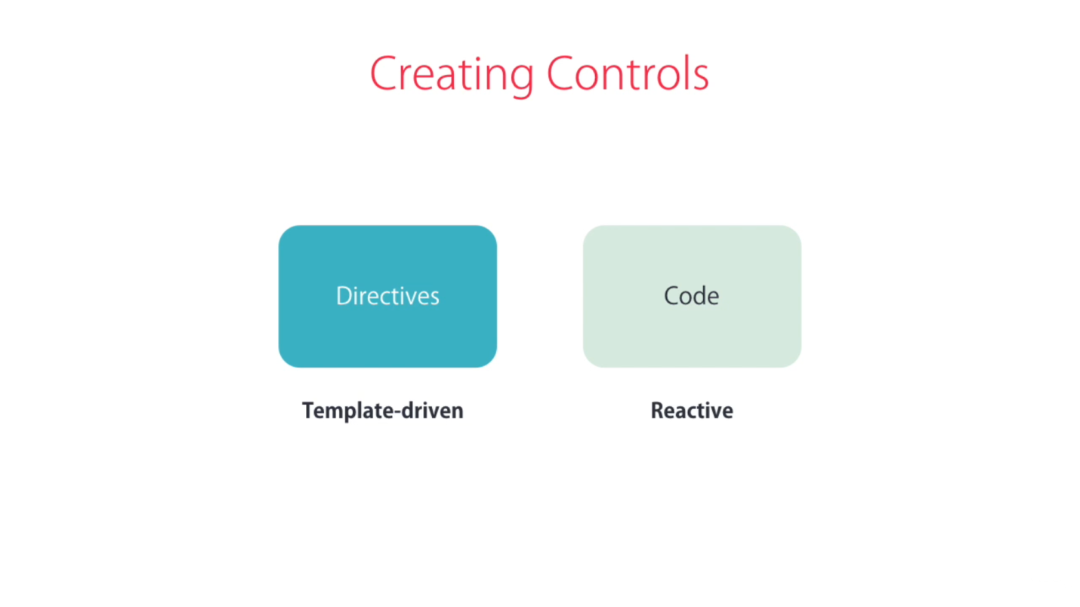

**There are two way to create a control object**

* One way to apply some directive in template
* Angular will create the **control object** **implicitly** under the hood
* We call the form build this way **template driven forms**. So we build them **using template**
* Another approach involves **explicitly creating the control object**.
* So in our component we should write a code to **create new instance of control group of control object**
* We call the forms build these way **reactive forms or Model driven forms**

**Difference between Reactive and Template-driven**

